

Pune Vidyarthi Griha’s
COLLEGE OF ENGINEERING, TECHNOLOGY AND MANAGEMENT, PUNE-09
Record No.: PVGCOETM/QMS/ACAD/R/46 |  | Revision: 00 | Date:1/7/2025

Unit Wise Question Bank
Department: Computer Semester: I Academic Year: 2025 - 2026

Class:SE Div: Course: Data Structure

Date:13/09/2025

Unit No. - name | Q. No. | Question | Marks | CO | Blooms Level
2  Searching and  sorting | Q.1 | Explain Linear search and binary search with example. State its time complexity and  compare linear and binary search(time and space complexity) | 6 | 2
2  Searching and  sorting | Q.2 | Write an algorithm for searching an element using binary search. Discuss the time  complexity of algorithm in best case and worst case. | 6 | 2
2  Searching and  sorting | Q.3 | .  Write an algorithm for Fibonacci search and find out its time complexity. | 6 | 2
2  Searching and  sorting | .Q.4 | Explain insertion sort algorithm and sort the given list using insertion sort :  1) List : 7, 4, 10, 6, 3, 12, 1, 8, 2, 15, 9, 5 2) List : 55, 85, 45, 11, 34, 05, 89, 99, 67 | 6 | 2
2  Searching and  sorting | .Q.5 | Write pseudo Python code for Bubble sort | 6 | 2
2  Searching and  sorting | Q.6 | Write a pseudo code for binary search apply your algorithm on the following no.to stored in array to search no. 23 and 100 .  9,17,23,40,45,52,58,80,85,95,00 | 6 | 2
2  Searching and  sorting | Q.7 | Sort a given array using bubble sort method:[64,34,25,12,22,11,90]  Show the step by step execution for all the passes highlighting the swap and No swap situation .how many passes are required to sort an array of the elements using bubble | 6 | 2


(for all engineering Resources)
https://whatsapp.com/channel/ 0029ValjFriICVfpcV9HFc3b

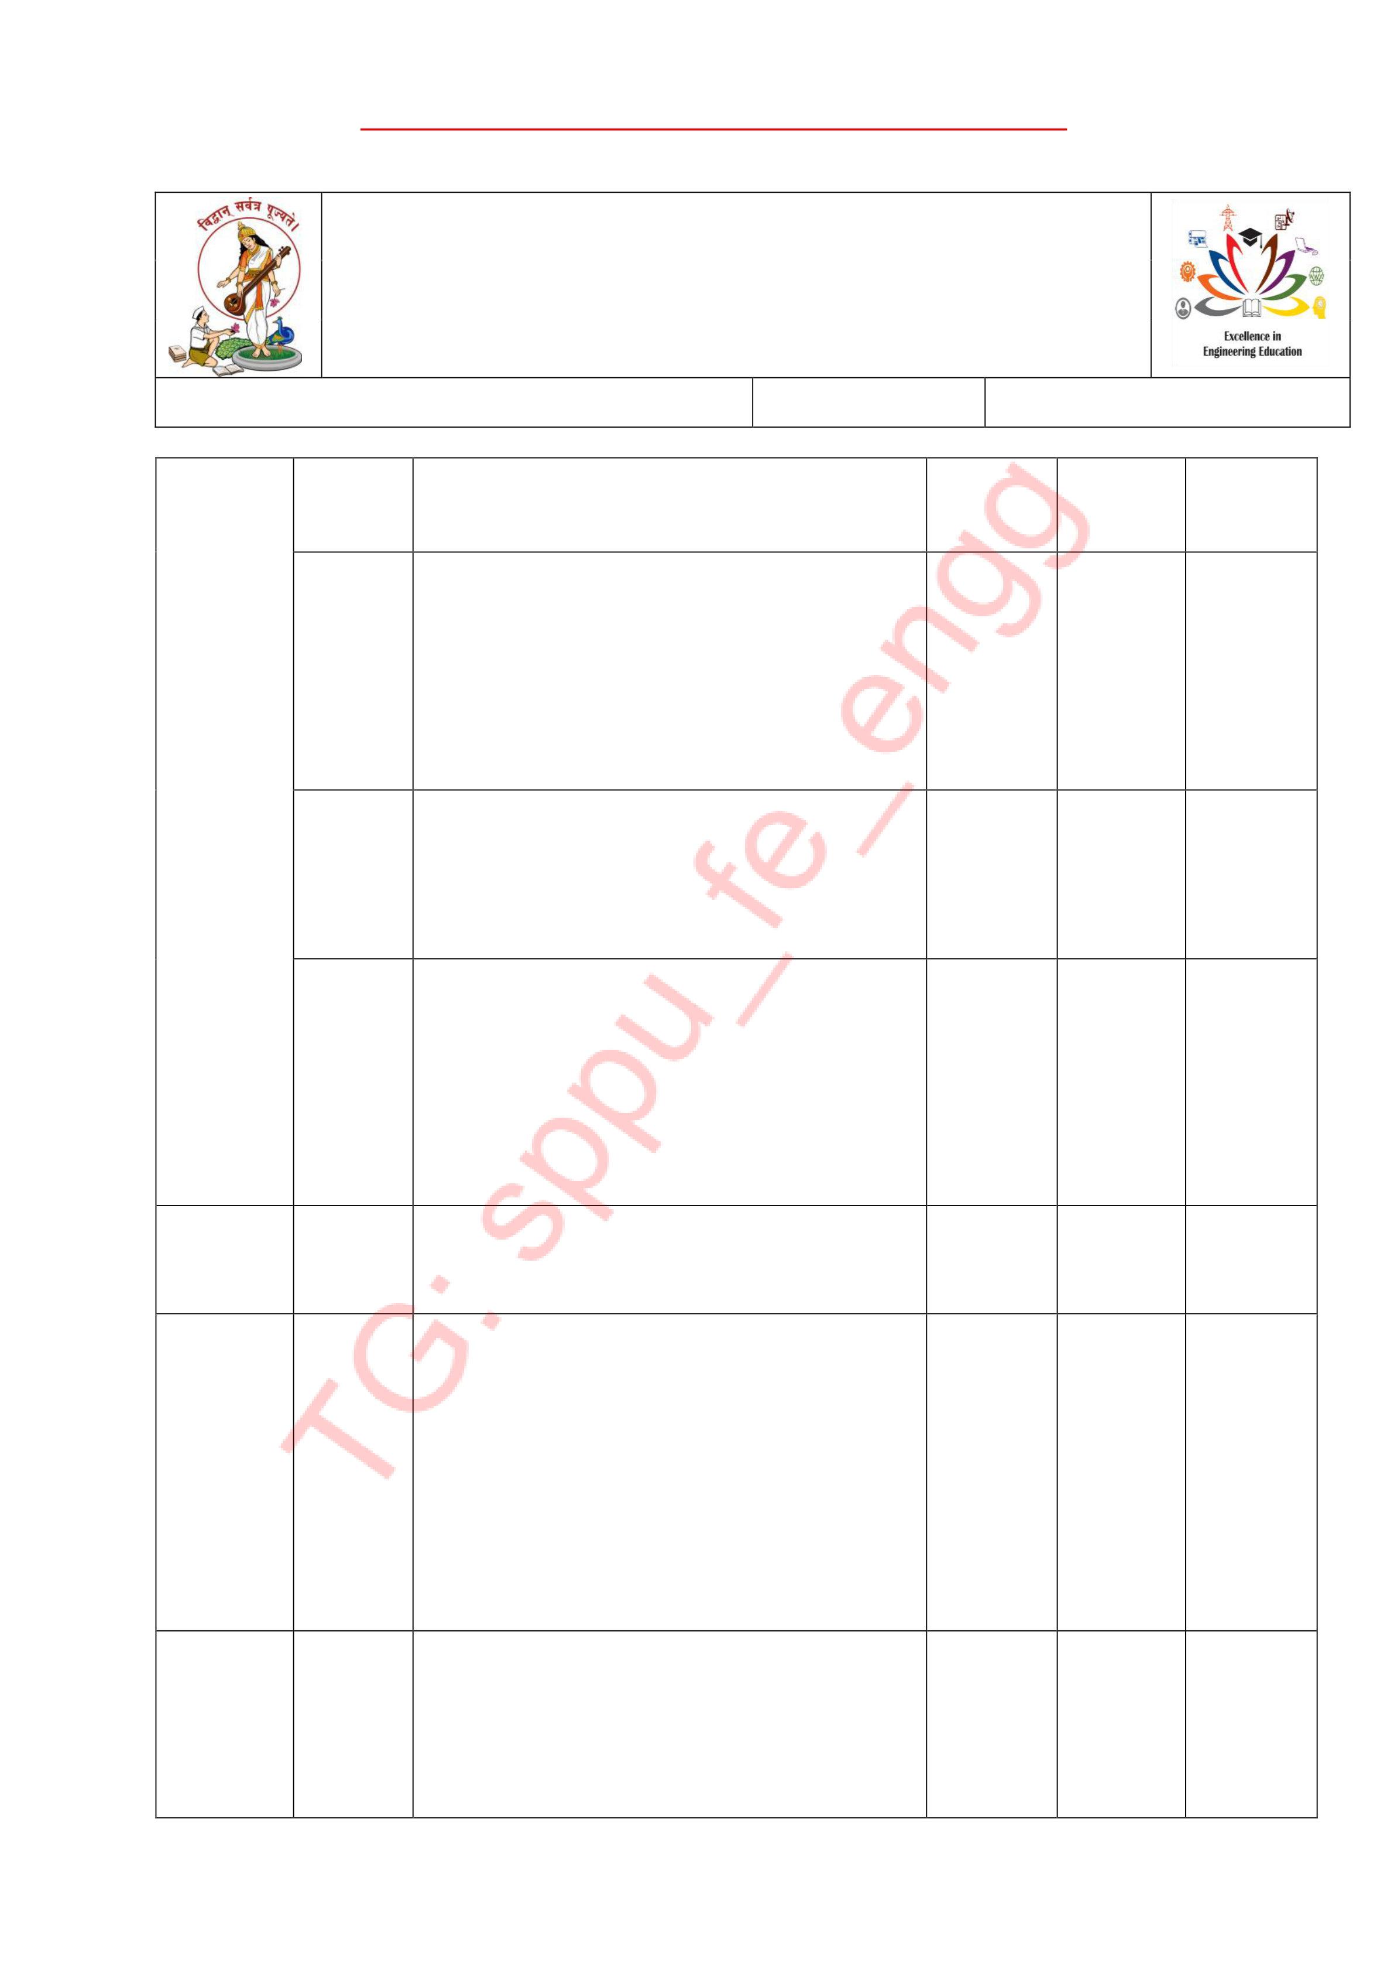

Pune Vidyarthi Griha’s
COLLEGE OF ENGINEERING, TECHNOLOGY AND MANAGEMENT, PUNE-09
Record No.: PVGCOETM/QMS/ACAD/R/46 |  | Revision: 00 | Date:1/7/2025

 |  | sort?
 | Q.8 | Enlist different searching methods.write short note on  i)Fibonacci search  Index sequential search. | 6 | 2
 | Q.9 | Explain in brief the different searching techniques. What is the time complexity of each of them. | 6 | 2
 | Q.10 | Sort the following numbers step by step using insertion sort 55, 85, 45, 11, 34, 5, 89, 99, 67  Comment on time complexity of Insertion sort. | 6 | 2
 | Q.11 | Explain in brief any three searching  techniques. What is the time complexity of these techniques? | 6 | 2
 | Q.12 | Write an algorithm to search an element in array using binary search technique. Show stepwise search of Key 10 in 1, 2, 3, 4, 5, 6, 7, 8, 9, 10,11. Is there any pre-  processing of data required before starting binary search or what is its precursor  requirement? | 6 | 2
 | Q.13 | Sort given array by using selection sort method 50, 23, 03, 18, 9, 01, 70,  21, 20, 6, 40, 04. Show step by step  execution of all passes. What is the best and worst case time complexity of | 6 | 2



Pune Vidyarthi Griha’s
COLLEGE OF ENGINEERING, TECHNOLOGY AND MANAGEMENT, PUNE-09
Record No.: PVGCOETM/QMS/ACAD/R/46 |  | Revision: 00 | Date:1/7/2025

selection sort?
Course Teacher

